ECON 2B03 Summary

Author: Kemal Ahmed

Instructor: Dr. Cameron Churchill

Date: Winter 2014

*Math objects made using* [*MathType*](http://www.dessci.com/en/products/mathtype/)*; graphs made using* [*Winplot*](http://math.exeter.edu/rparris/winplot.html)*.*

# Chapter 1 − Sustainability

**model**: an simplification of reality that captures information useful and appropriate for a specific purpose

**linear product lifecycle**: energy in and out at every stage

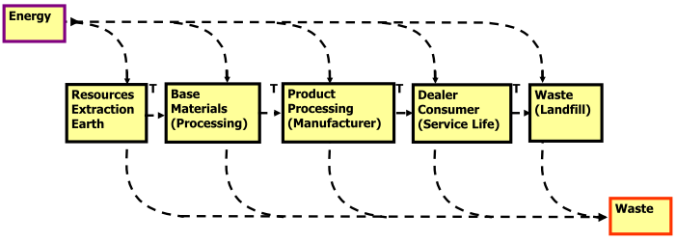

**closed-loop product lifecycle**: recycling, re-use, energy only lost at consumer level

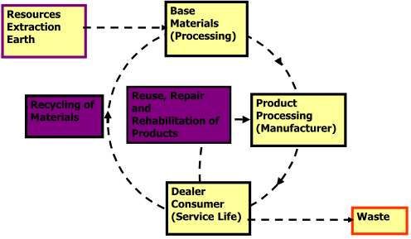

**Ingenuity Gap**: the gap between requirements and solutions, which is caused by an increasing complexity (?)

## Triple-Bottom Line

Focuses on:

* **Social sustainability**: productive service to society
* **Environmental sustainability**: resources/land
* **Economic sustainability**: cost efficient

## Seven Revolutions

1. Markets: compliance to competition
2. Values: hard to soft
3. Transparency: closed to open
4. Life-cycle Technology: product to function
   1. Companies responsible for entire product life-cycle
5. Partnership: subversion to symbiosis
   1. Companies cooperate
6. Time: wider to longer

# Chapter 2

**Cash-flow period**: time over which you are calculating effective interest rate

Don’t forget that there are 4 quarters in a year and 3 months in a quarter-year.

*r*: nominal interest rate (interest rate over a year)

*k*: number of periods per cash flow period

**Effective Interest rate: **

Your effective interest rate should be close to nominal interest rate/cash-flow periods per year.

# Chapter 3

**Equivalence**: (?)

**Market Equivalence**: (?)

**Decisional Equivalence**: (?)

**Mathematical Equivalence**: (?)

**Annuity**: series of cash flows (?)



F is known, such that you know how much you will get in the end, but will be split up into multiple payments. For example, take salary.

Note: if you pay at the end of your annuity, you don’t get any benefit from interest. Look out for when the first payment is paid (whether at the end or beginning of the period). The default is at the end of the first year.

Uniform Series Compound Amount

Factor:

Note: do not average to 4 weeks/month.

# Chapter 4

*k* = *m* for annual